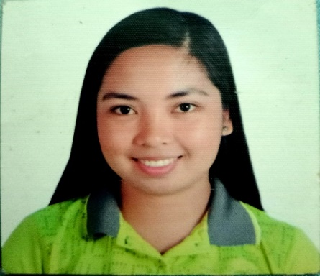Jedidiah T. Morales

09614231687

[jedd2817@gmail.com](mailto:jedd2817@gmail.com)

1225 Sta. Monica Village, Ugong,

Valenzuela City Philippines 1440

**Objective:**

Pursuing opportunity which will allow me to grow professionally, while effectively utilizing my versatile skill set to help promote your mission and exceed team goals.

**Summary of Qualifications:**

Extremely motivated and passionate in whatever I choose to do. Strong interpersonal and communication skills and know how to handle and deal with different kind of people and circumstances.

**Skills:**

Knowledgeable in Microsoft Office such as Word, Excel and Power point

Ability to motivate and persuade others

Customer Service capabilities

Communication and Leadership

Multi-Tasking Ability

**Experience:**

**Guest Experience Leader and Service Crew**

Mcdonald’s Puregold Paso De Blas (Mcmagik Corporation)

East Service Rd. Barangay Paso De Blas Valenzuela City

November 18, 2018 to January 2023

**Educational Background:**

* **Tertiary :** Bachelor of Science in Pharmacy

Araullo University – PHINMA, Cabanatuan City Nueva Ecija

(S.Y. 2014 – 2016)

* **Secondary :** Vincentian Catholic Academy
* **Primary :** Don Cirilo B. Acosta Elementary School

Character reference is available upon request:

I hereby certify that the above information is true and correct to the best of my knowledge and belief.

JEDIDIAH T. MORALES